Chapter 16, Problem 33.

Using Fig. 16.56, design a problem to help other students to better understand how to use Thevenin’s theorem (in the s-domain) to aid in circuit analysis.
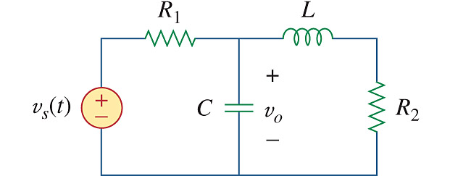

Figure 16.56
For Prob. 16.33.

